*Ex db ib [ib] IIB T4 Gb*

*Ex ib [ib] tb IIIC T130°C Db*

Health and safety standards (QHSE) for protecting personnel and plant assets require implementing counter measures for explosion hazards.

During loading and unloading of Non-conductive flammable liquids and powders electrostatic charge is generated on conductive objects (Trucks, Railcars, Rail tankers, Barrels, Drums, Big bags, IBC, Skids, LACT units).

To mitigate hazardous level of energy for spark formation and ignition of material atmosphere, earthing and continues monitoring is required during complete loading and unloading processes

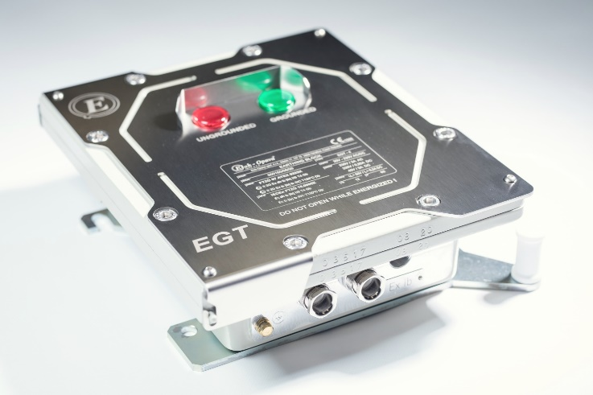**EGT specific features**

* Extreme temperature range
  + -55 °C - +60 °C
* Season control
  + Robustness from change in ground conductivity variation between summer and winter season
* Wireless parameter change
  + Bluetooth / IrDa impedance level monitoring and setting
* Ultra-wide input supply range
  + 20V DC to 350V DC
  + 20 V AC to 230 V AC /  47 ~ 63 Hz

### System EGT

**EGT basic function**

1. Initial safe electrostatic discharge
   1. By connecting earth to discharging point
2. Operators error control (earthing object detection)
   1. By Impedance measurement and check
3. Continuous earthing and monitoring of correct earthing during filling process
   1. By resistance measurement and check
4. Process blocking and signaling
   1. Two DPDT (double-pole double-throw) for process control
   2. High visibility LED for system check

Certificate IECEx FTZU 15.0005X

Protection Ex db ib [ib] IIB T4 Gb

Ex ib [ib] tb IIIC T130°C Db

Ingress Protection IP65

Ambient Temperature -55°C to +60°C

Voltage range DC 20 V DC ~ 350 V DC

Voltage range AC 20 V AC ~ 230 V AC

Power input 10 VA

Output circuits 2x potential-free switching contact

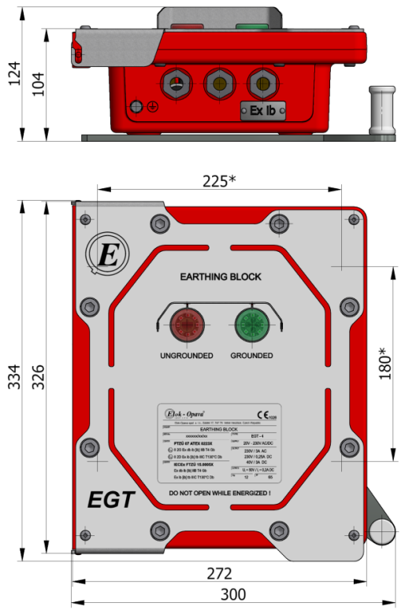Bluetooth version 5.0 LE (Low Energy)

IrDA interface USBIR 1 for IrDA

Weight 10,4 Kg

* **Type**
  + **EGT 4**

Flameproof enclosure, ingress protection IP 65, typical target area: petrochemical industry

****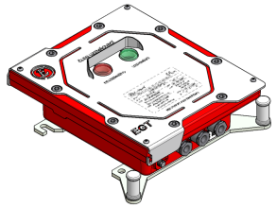

* + **EGT4S**

Flameproof enclosure made of stainless steel, protection IP 65, typical target area : offshore petrochemical

****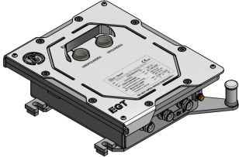

* + **EGT P**

Stainless steel box, ingress protection IP 65, typical target area: food or pharmaceutical industry

****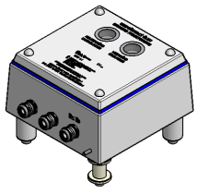

**Sectors of application:**

* Petroleum refineries - transport of crude oil, petrol, diesel
* Fuel storage depots - loading of petrol, diesel, kerosene
* Onshore facilities
* Chemical and petrochemical facilities (flammable liquids, alcohol, organic solvents)
* Paint industry
* Pharmaceutical industry (Big bags, dust environment)
* Food industry (ethanol, alcohol, grain, fertilizers handling)

### Accesories

IrDA interface



Calibration set for IrDA interface

Self-retracting cable Reel

Multiple language versions (EN, DE, CZ, PL, RU)